HEPATITIS AVIRUS IS SPREADING: GET IMMUNIZED

Why should I care

about Hepatitis A?

I think I may be at risk for catching Hepatitis A. What can I do?

How Does Hepatitis A Spread?

Several states have outbreaks of Hepatitis A. The disease can easily spread from person-to-person and cause serious liver disease lasting a few weeks to many months. Some people die from Hepatitis A. If you are using drugs or living on the streets and in shelters, you are at greater risk for catching Hepatitis A.
- Get the Hepatitis A shot!
- Wash your hands with soap and water after using the bathroom and before eating or preparing food
- Avoid having sex with people with Hepatitis A
- Don’t share toothbrushes, food, drinks or smokes

What are the symptoms of Hepatitis A?

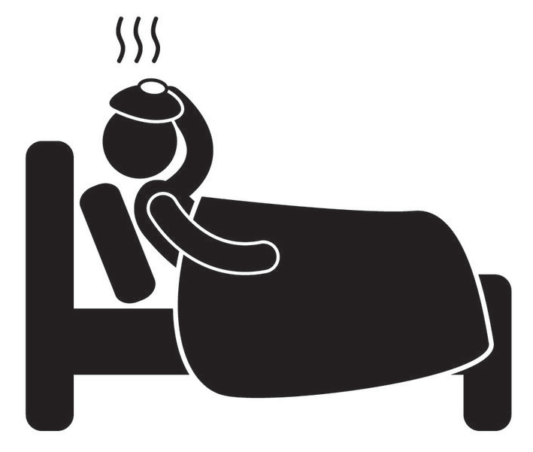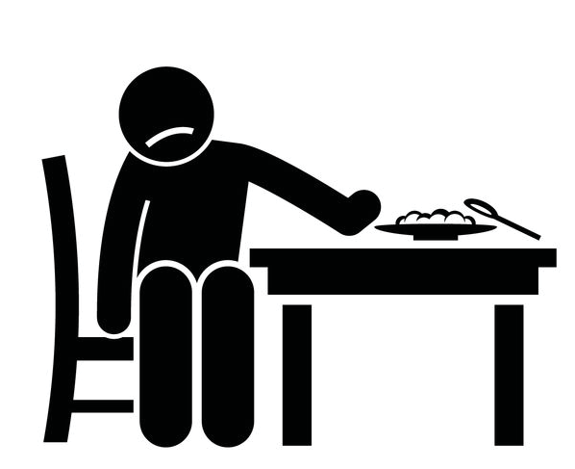

Fever
Fatigue Nausea
Loss of appetite

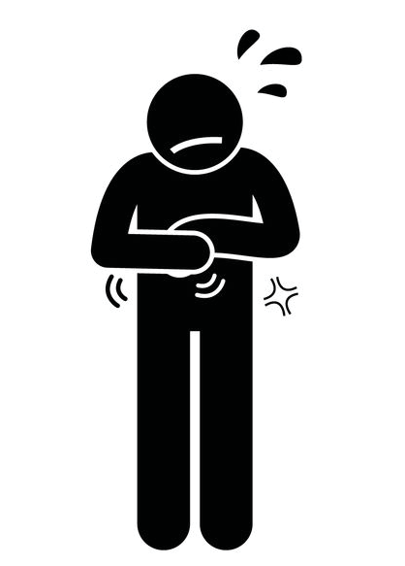

Jaundice (yellowing of the skin or eyes)
Stomach pain
Vomiting Dark urine, pale stools, and
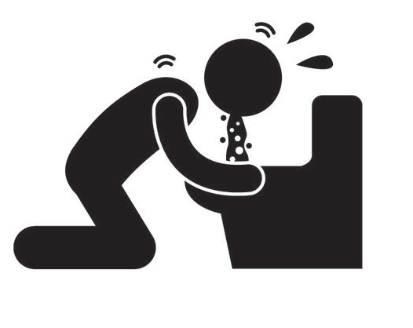
diarrhea

If you think you have Hepatitis A, see your doctor or visit the closest Emergency Room.

- Contact [enter contact information for your county here]
- Dial 2-1-1 on your phone to learn where you can get the Hepatitis A vaccine
For More information

